1,828 words
Reframing Migration: The U.S.-Mexico Border from Multiple Perspectives

Migration has existed throughout history, but over the last decade, it has become a heavily discussed and prevalent topic in the Western world, especially in the United States. The work of anthropologist Anna Laura Stoler on colonial history introduces key concepts that help explain how migration is currently portrayed in the media and understood by the public. In her chapter “Critical Incisions: On Concept Work and Colonial Recursions,” Stoler connects the concept of duress to colonial histories. Stoler provides four dictionary definitions of duress, two of which are particularly useful for this essay: the definition “Harsh or severe treatment, infliction of hardship; oppression, cruelty; harm, injury; affliction” and “Forcible restrain or restriction; confinement, imprisonment”. Another central term in Stoler’s chapter is occlusion, which, in relation to colonialism, she views as a process that creates complacency by leaving out, misnaming, or silencing histories. The continuous malleability of occlusion parallels how colonial histories are obscured. The concepts of duress and occlusion to colonial histories will be used as a lens to analyze visual artifacts related to the U.S.-Mexican border and migration. The five artifacts chosen are divided into three categories: two from the Mexican border, two from the U.S., and one that represents the overlap between the two. The Mexican visual artifacts are Alex Rivera’s film Sleep Dealer (2008) and Griselda San Martín’s photograph Family Portrait (2016). From the U.S. perspective, the performance art piece Teeter Totter Wall (2019) and NPR’s website Borderland (2014) will be used. The final artifact, Ana Andrade’s Last Night At Playas de Tijuana (2017), displays the overlap and intersection of the borders.
In contemporary media, migration is often oversimplified with labels such as “illegal” and “alien” that invite negative connotations. This dehumanization reduces migrants to one-dimensional figures. As Lilie Chouliaraki and Myria Georgiou argue in their chapter “Introduction: The Digital Border: The Techno-Symbolic Assemblages of Power,” this one-dimensional portrayal is created through migrants being reduced to numbers and statistics. Furthermore, through the constant association of migration with the word “crisis”, art historian Britta Anderson notes that “a constant state of alarm” is created. This alarm results in a collective numbness, making it difficult for the public to understand and perceive the realities of migrant experiences. The visual artifacts selected for this dossier are examples of migration that aim to make these dehumanized narratives more human.
The first artifact, Sleep Dealer, represents migration along the U.S.-Mexican border. Released in 2008, the film is a science fiction work set in a dystopian future, exploring the intersection of migration and labor. The film follows Memo Cruz (Luis Fernando Peña), a remote factory worker who performs labor intended for the U.S. while physically residing in Tijuana. To work remotely, factory workers like Memo are marked with nodes on their bodies, which allows them to access the American workforce virtually, eliminating the need to cross the border. In this narrative, migrant labor is made invisible by relocating it to a virtual space. The node turns the workers into machines that extract energy from their bodies (Fig. 1). This extraction aligns with Stoler’s concept of occlusion; like colonial histories, the workers’ labor is hidden from view. One scene in the film that highlights this is the visual superimposition of wires connecting the workers’ bodies over an image of a water pipeline. The labor of the workers is being extracted and exploited, and the node reflects similarities of the continuous challenges of nationalizing and privatizing natural resources in Latin America. In this context, the node symbolizes both the labor of the workers and the larger, systemic extraction.
Migration is additionally understood and represented in this film through the virtual border. For the characters in the film, the node is a literal manifestation of the border on the body. Once the workers disconnect from their workday, they are left with the scar of the node, a permanent reminder of their labor and the barriers they face. When discussing the genre of science fiction, comparative literature professor Sarah Ann Wells introduces the concept of border science fiction, which probes the globalized nature of contemporary labor relations. Wells argues that science fiction, through its imagined future, acts as a commentary on the present. Sleep Dealer is an apt example demonstrating the extremities of closed and militarized borders, showing how, even in a virtual world, the consequences of migration are felt in the body, particularly through the physical incision of the node.
The second artifact chosen is Griselda San Martin’s photograph Family Portrait (Fig. 2). Shot in 2016, the photograph is part of San Martin’s series The Wall, which explores the separation of families at Friendship Park. Friendship Park was created in 1971 as a space of unity and access for migrant families to interact with one another on the Mexican side of the border. This unity slowly dissolved with the implementation of a secondary fence on the American side in 2009, which is made up of a twenty-foot-high barrier of steel bars extending 300 feet into the ocean and covered in security cameras and sensors. In 2016, the Mexican side of the border is decorated with murals and does not have border patrol agents, which is why San Martin chose to work there in Tijuana. In her article, “Family, Diaspora, and the Politics of Care in Griselda San Martin’s The Wall, 2015-16”, art historian Sarah Bassnett notes how San Martin’s work recognizes familial ties by taking on the subject matter of family portraits. In Family Portrait, the woman on the Mexican side is framed by a mesh fence, and her family members on the U.S. side are essentially shadows. Although posing with her family, the woman does not smile, and her posture is closed off, with her hands grasping each other rather than attempting to reach for her family. The work highlights how migration laws in America physically separate families, even when meeting with each other in spaces of ‘unity’ such as Friendship Park, their interaction is very limited. With this photograph, Stoler’s definition of duress as “Forcible restraint or restriction; confinement, imprisonment” can be applicable. The family is put under duress through their separation, and the image of the mesh fence emulates that of confinement and imprisonment, limiting and restricting the possibilities for reunion and closeness.
The third visual artifact is the performance art piece Teeter-Totter Wall (Fig. 3) by Ronald Rael and Virginia San Fratello with Colectivo Chopeke. Unlike the other two examples, this work is a performative piece enacted on July 28, 2019, and lasted for forty minutes. Performance art, as understood by art historian Britta Anderson, distinguishes itself from other media in that it is a creative tool that can destabilize and transform crisis and violence. Due to its playful nature, its playground function, and its hot pink color, Teeter-Totter Wall received a lot of criticism online for its obscuring of violence by transforming the border into an area of play. Anderson asserts that the piece does not conceal this violence but instead coexists within it. Although the shade of the teeter-totter seems to be cheerful, it reveals a darker theme. The hot pink color of the teeter-totter was chosen in relation to pink crosses that were mounted across Ciudad Juárez as a sign of mourning and protest for the women who had been murdered. The playfulness of the live art attempts to frame migration in a different light. Unlike the numbness experienced through the consistent horrors broadcast on the news or in articles, as discussed above, Teeter-Totter is a short-lived instance of community and unity, creating a shared moment of humanity and joy even as it highlights the contrasts between the two sides. On the left, the U.S. side, the landscape is pristine and tidy, while on the right, the Mexican side, the terrain is littered with weeds and trash. The Teeter-Totter Wall represents the fleetingness and consistent transformation of migration laws and practices; one moment it is in action, and in another it has ceased to exist. The photograph of this performance art fights back against occlusion, showing the two sides of the border at the same time and their different realities.
The fourth visual artifact chosen is NPR’s Borderland project, which is a website and multimedia documentary series recording a “2,428-Mile Road Trip along the Mexico border” that explores personal stories of immigration, trade, and crime. Spearheaded by American journalist Steve Inskeep, the project documents an American perspective on the U.S.-Mexican border. The project was divided into 12 sections. One particularly interesting section is the “Story 8: Toothbrushes” with the subtext “Things left behind,” which explores the personal items migrants abandon as they travel across the border, such as toothbrushes and deodorant. These discarded hygiene products humanize the migration experience, moving beyond the politics of the issue to focus on the everyday lives and lived experiences of migrants. By focusing on personal stories and mundane objects, Borderland provides a powerful counterpoint to the sensationalized media coverage of migration.
The final piece chosen for this collective is Ana Andrade’s video installation Last Night At Playas de Tijuana (2017) (Fig. 5). Andrade defines herself as a transborder artist, meaning she splits her time between Mexico and America, living in both Tijuana and San Diego. This work reflects her unique perspective on the border. In this video installation, Andrade abstracts water and matter from Playas de Tijuana and examines them on a microscopic level. Through this minimization of water and matter, and more greatly the border, Andrade minimizes the duress experienced by migration. In her artist statement, she writes, “Human race tends to control the flux of bodies in displacement, blocking or redirecting the mobility of nature. With this piece, Andrade symbolizes the arbitrary nature of borders, emphasizing how they are imposed on both humans and the environment. The abstracted piece provides a different perspective in comparison to the other four selected works that have the human body as central to the narrative. This abstraction provides the opportunity to step back and assess one’s positionality, reminding the viewer that the world is much more nuanced and intricate than it may seem on the surface.
Within this dossier, the five visual artifacts chosen, using Stoler’s concepts of duress and occlusion as a framework, attempted to represent migration in relation to the U.S.-Mexico border in various ways. From a Mexican perspective, as demonstrated with Sleep Dealer and Family Portrait, to the American viewpoint in Teeter-Totter Wall and Borderland, and finally through a transborder perspective of Last Night At Playas de Tijuana. Each piece reveals different aspects of the border, its restrictions, and the lived experiences of migration. Although they are relatively older examples, such as that of Sleep Dealer, they remain relevant to current U.S.-Mexico border debates with the expansion of a ‘virtual border’ as seen with the increased use of surveillance technologies (towers, cameras, sensors, drones), and AI data integration. These works resist the dehumanization of migrants, visually illustrating the ongoing struggle for dignity and connection in the face of oppressive systems.

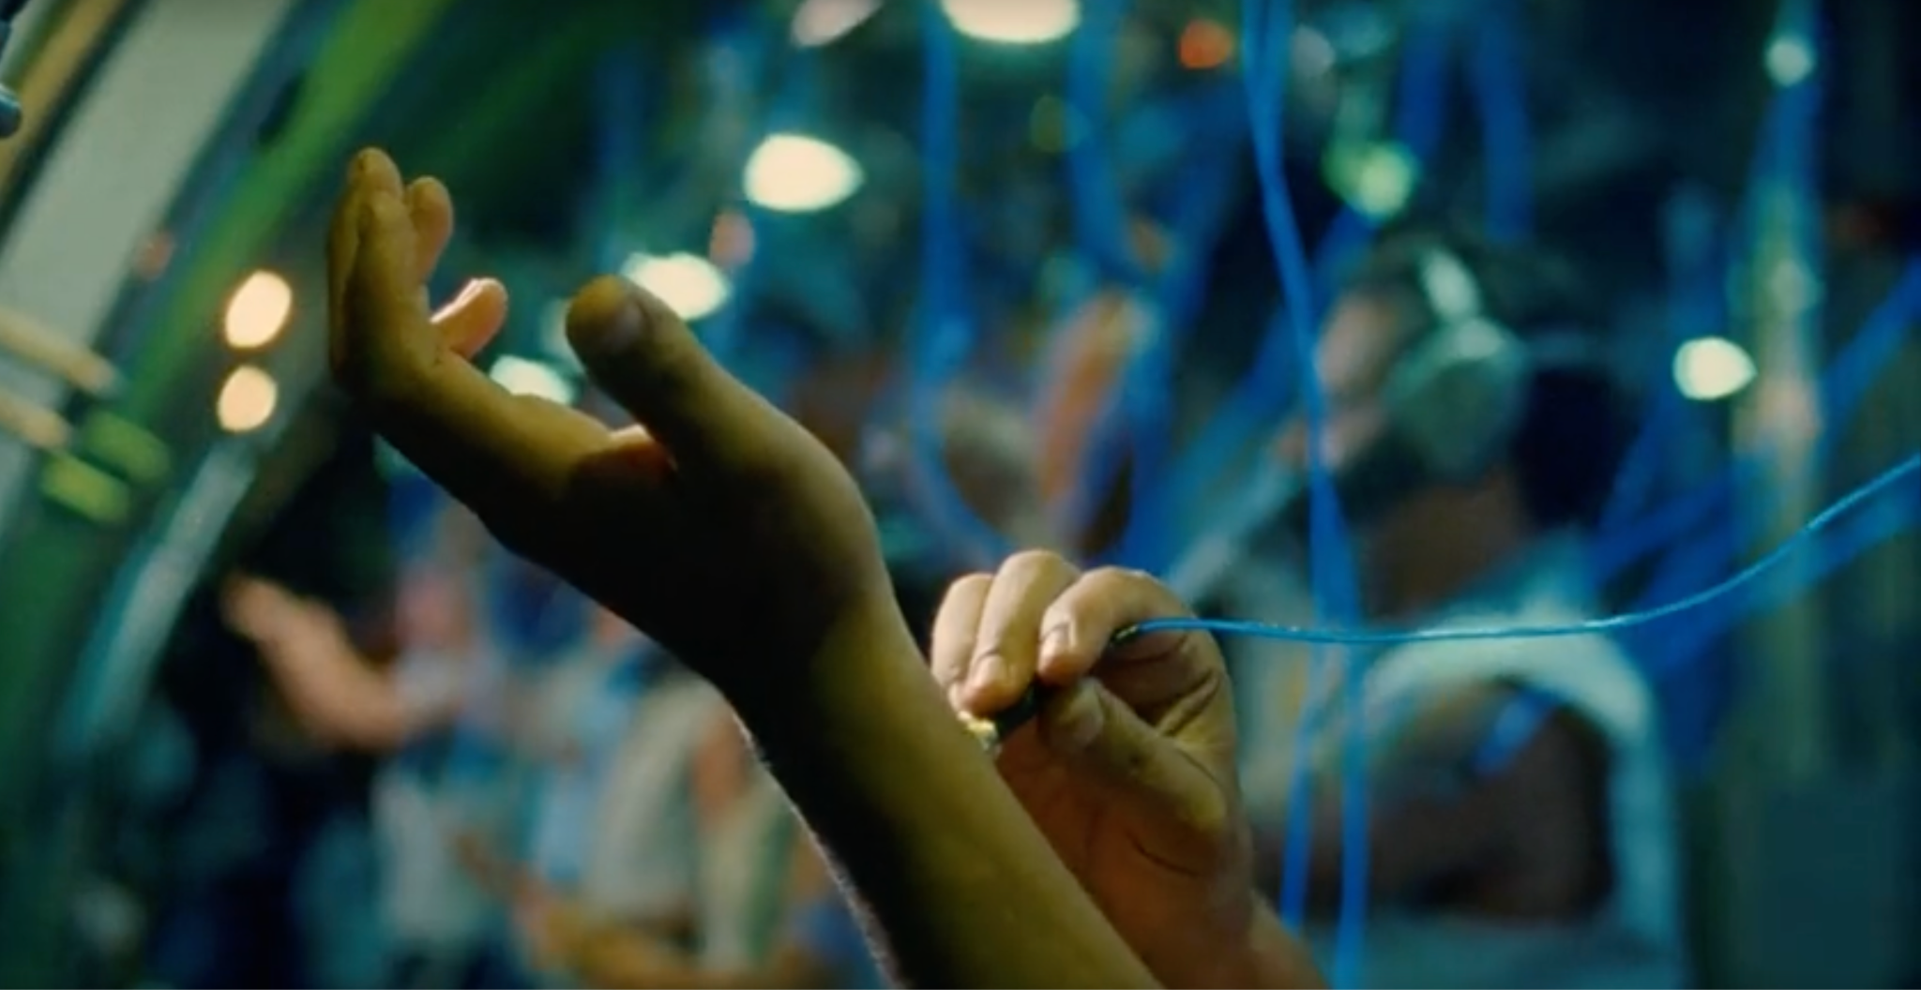
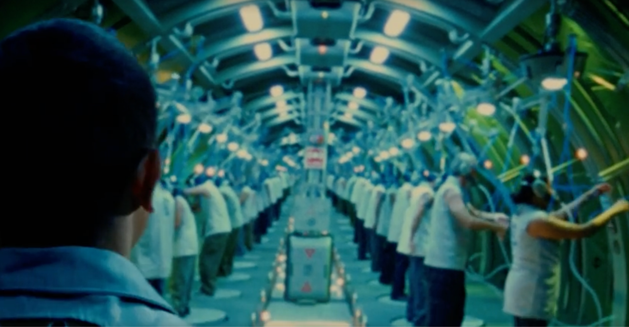
Figure 1. Screen grabs from the factory where Cruz works. The top screen grab displays Cruz connecting to the working network through the node in his hand. The bottom screen grab showcases the work setup, it is a crowded space, and the workers are reduced to almost being cogs in a machine, as showcased with all the wires they are attached to.

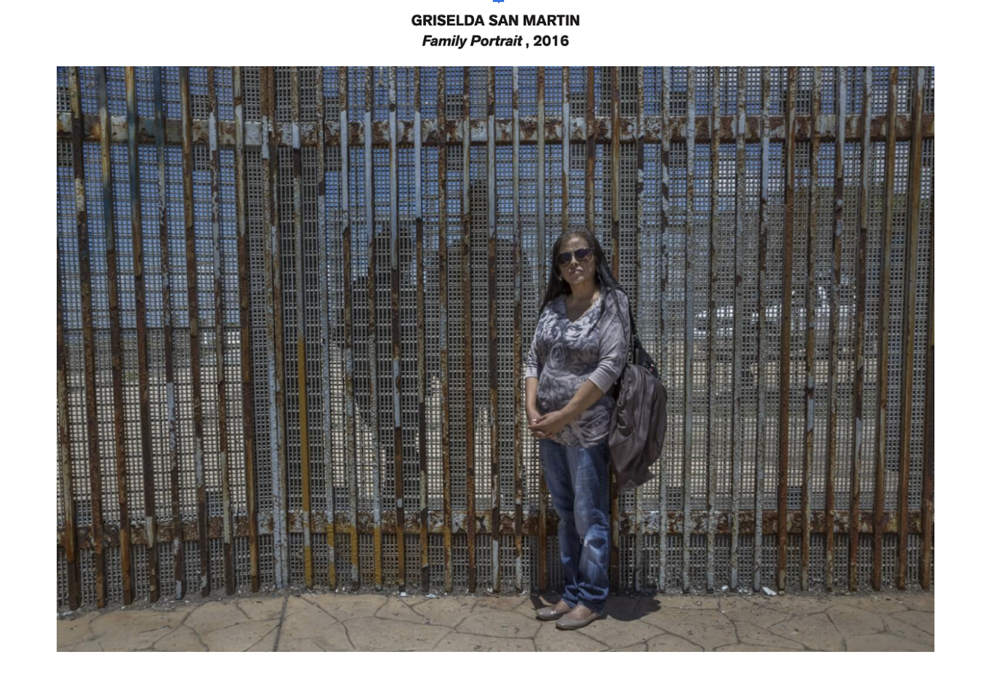
Figure 2. Griselda San Martin’s photograph Family Portrait from 2016.

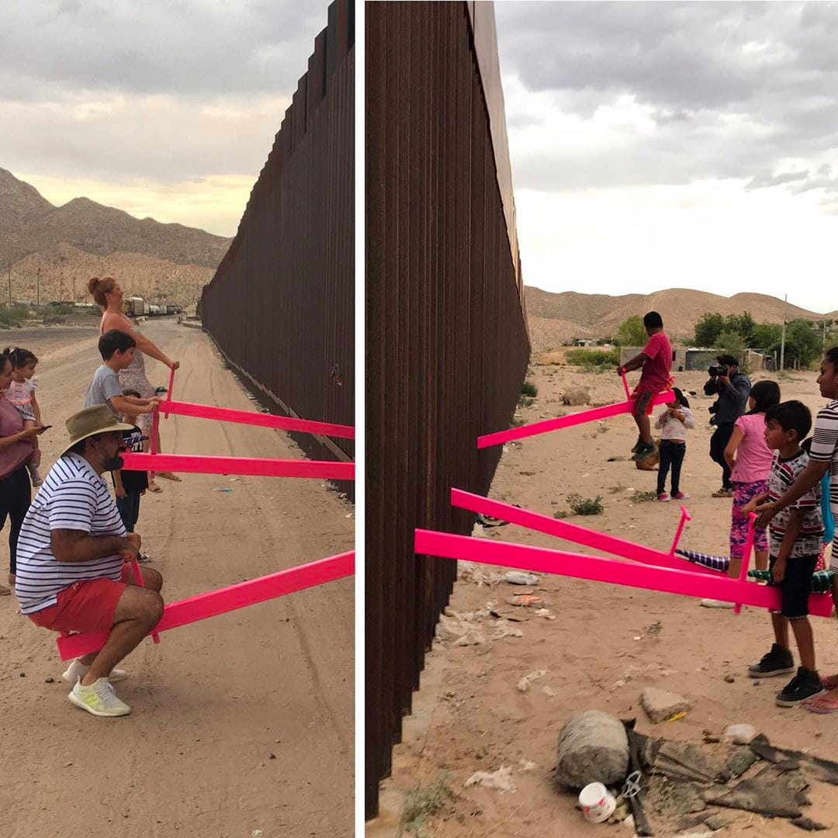
Figure 3. Two photographs by Luis Torres of the Teeter-Totter Wall that provide a viewpoint of the American and Mexican border simultaneously.

)
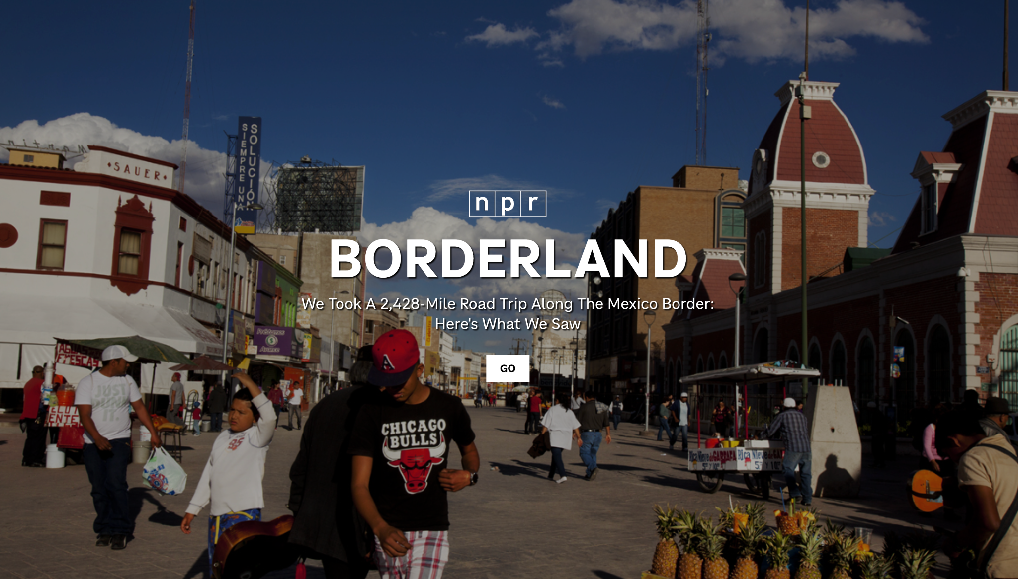
Figure 4. Screen grab of NPR’s website for their multi-media documentary project. This screen grab shows the first page you see when accessing the website.

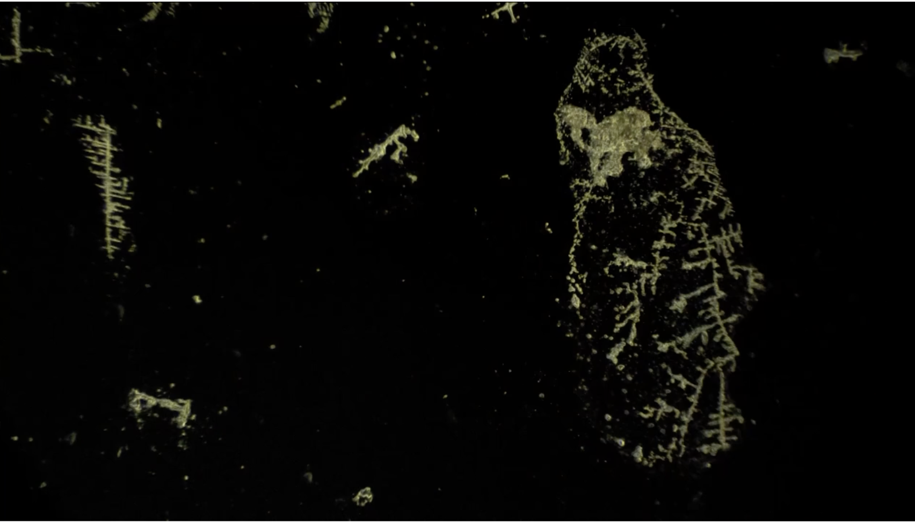
Figure 5. Screen grab of Ana Andrade’s video installation Last Night At Playas de Tijuana. Pictured is water and matter enhanced through a microscope.

1,768 Words
Understanding the Contemporary through the Past: Zachęta National Gallery’s Perspective on Polish Migration
In their exhibition, “What are Our Collective Dreams? Global Connections - Abandoned Friendships,” the Zachęta National Art Gallery in Warsaw, Poland, directly addresses the topic of migration in a highly self-reflexive manner by looking at Poland’s history with migration and Zachęta’s own relationship and interaction with migration and immigrating artists. This self-reflexivity is demonstrated through the discussion and inclusion of artworks from previous exhibitions held at the gallery. Upon entering the exhibit, the show’s introductory wall text outlines five categories, which can be used as frameworks and central themes in understanding the artworks and allowing the visitor to form their own narrative. The first theme is “non-western knowledge production”, the second is “imperfect solidarities”, the third is “the politics of poetics”, the fourth is “extractivist practices”, and the final is “the politics of intimacy”. To create a narrative structure, the display, as taken from the introductory wall text, is a conglomeration of “artworks, archival records, and contemporary voices.” Through these various media and techniques, the exhibit constructs a narrative of migration that is global but centered on Poland.
Within the first room, there is a large map of the world drawn on the wall. Overlaying the map are twelve artworks that are each connected to a green line, tying them back to Poland. The artworks, as outlined by the wall text, are defined as showcasing Poland’s relationship, “with countries of the Global Majority, including India, Vietnam, Palestine, and Latin American countries”. This map shows the relationship of Poland with the world on a global scale. Visually, the map and overlaid artworks are very captivating, allowing the visitor to reflect on the role of Poland on an international scale and the migration of art from Poland to the international and the international to Poland during the Cold War (Fig. 1). Within this series of works, there was one artwork that stood out to me, and that was the painting Cage by Polish artist Teresa Pagowska from her ‘The Chile series’, painted in 1973. The wall text of this work is very brief, giving the visitor the name of the artist, work, the year it was made, material, and a quick description discussing the political context in which the work was made in: “It was painted under the influence of reports and press photographs from Chile following the coup d’etat carried out by Augusto Pinochet.” This description left me wanting to know more about the artist, which aligned with the curatorial goal of providing “visitors [with the tools to] construct their own narratives and forge their own experiences”. As a way to start and set up the thematic and narrative structure of this exhibit, that of global connections and the exchange of art, in turn, migratory artistic practices, this wall was successful, providing historical context from the Cold War era on which the exhibit focuses on and including older art pieces that the gallery had exhibited before.
The first room additionally extends its contextualization by including a mural specifically commissioned for the exhibit, which positions the show within a contemporary social framework (Fig. 2). The mural, as underscored by its label, was “created for the context of Poland” by Minerva Cuevas, a Mexican conceptual artist. In the mural, Minerva Cuevas undertakes the topic of the hardening of borders, depicting the Polish Belarusian barrier. The wall text goes into the historical significance of this mural, where a similar art project was supposed to be implemented for Warsaw’s 10th-Anniversary Stadium in 1955 by Mexican painter David Alfaro. This project was abandoned due to Cold War pressures steeped in political rivalries. Once again, this label elucidated the context of the image but allowed the viewer to go deeper into exploring the work. For example, one of the main ways the image situates itself as the Polish-Belarusian barrier is through a small signpost to the left of the mural, which reads NAT Bilowieza 2021, which is the largest preserved woodland in Europe that stands at the border of Poland and Belarus and is home to a free-roaming European bison population. The balance of what is included and not included in the label leaves the viewer to do much of the sleuthing and research on their own. One can maybe recognize animals native to both countries, Poland and Belarus, such as the beaver, badger, and boar. Further nuance is added to the work through the juxtaposition of the animals and red barbed wire; unlike people, animals do not pay attention to the limitations of borders, crossing where they would like, like the bird in the image, or building their own border, like the beaver with its dam. Similar to the fluidity of animals crossing the border, the commissioning of this artwork specifically for the exhibition incites a question of temporality, as the mural will come down with the take-down of this show in February, potentially reflecting the constant changing and evolving of migratory practices and redefinitions of borders. Beyond the painted mural, the theme of migration and surveillance is additionally addressed with a painted surveillance camera depicted next to a physical one. The visitor is surveilled in a manner similar to the animals in the image and migrants at large. Through the commissioning of Minerva Cuevas, who provides an outsider perspective, the curators create a broader, global understanding of the Polish Belarusian border.
Moreover, the exhibit successfully engages the visitor with the topic of migration physically. In the third room, there is an interactive artwork of swings by Marina Naprushkina. Attached to each swing is a slogan in various languages: Belarusian, Polish, and English. One swing with English text reads, “Soil without memory, body without rest.” The use of these multiple languages demonstrates that the world is not uniform. The wall text reads “The swings embody instability: to swing is literally to feel the ground moving under your feet. That is heightened today by militarization, wars, rising xenophobia, and anti-migrant rhetoric.” In a very heavy exhibit discussing topics of exclusion, the swings offer a weird moment of relief, a childlike whimsy with the activity of swinging mixed with instability. By being the third room, in the middle of the exhibit, the placement of this installation is successful in breaking up the experience. The swings are meant to be a moment of reflection for the visitor, where they get to choose which slogan they will sit under and represent. This installation received one of the longest labels that extended Naprushkina’s work beyond her artistic practices to her community engagement with projects such as Neue Nachbarschaft/Moabit, which is a community center in Berlin that supports refugees and residents through cultural and social programs. With this explanation, the installation moves past the room that it is placed in and expands to discuss migration on a larger scale, moving away from the impact of art to the impact of the community, and how these two practices can go hand in hand.
In the last room of the show, migration is once again addressed with the work Drop it Off Station. The work is an installation that includes a screen with a group of phones to the left of it. The phones are all placed on tripods and are bombarded with text alarms that go off perpetually. These alarms can be heard from the previous room, already encouraging engagement with the piece before entering. This pinging of the phones is confusing at first, but upon a closer look at the phone screens, one can see that each message is related to food delivery. While the phones go off, the screen shows food delivery drivers talking about their working experience: a taxing job that does not have many benefits. The workers share their dreams and aspirations, with most of them being migrants in a new country (the three countries represented within the project are Pakistan, Zimbabwe, and Belarus). Unlike the other installations, this piece worked exceptionally well even without the wall text. The proximity of the phone, which had the delivery instructions, to the screen, which had the narration of couriers, helped contextualize and frame the work (Fig. 3). Yet, the label added the nuance of the app-based food delivery services being controlled by a corporate algorithm. These workers do not have a physical boss but are rather left at the whim of an algorithm. The artists of this work, Marta Romankiv and Weronika Zalevska, in collaboration with Alaksandr Blearuki, Takunda Charlton Dzikiti, Eshwet Dube, Syed Talha, and Mubashir Hussain, attempt to display “the privatization of migration and the deregulation of the labor market,” where working conditions and human rights of migrants are questioned because of their literal dehumanization with the lack of a physical boss. For the viewers of this installation, the room has pillows and seating areas alongside the walls, inviting visitors to sit down and experience the video. Rather than having benches, the curators invite a more intimate experience by using the pillows. This seating arrangement, placing the visitor closer to the ground, resembles a watching at home experience, which meshes well with the screen that is placed on the ground and short tripods.
Overall, migration is explicitly addressed in Zachęta’s exhibition “What are Our Collective Dreams? Global Connections - Abandoned Friendships,” which creates an engaging visitor experience to reflect on the role of global connections and, in turn, migration practices. Situating the topic of migration in Poland and the Zachęta’s own positionality was particularly strong in that it allowed the show to ruminate on the past in order to engage with the present and contemporary artwork. The couple of works and rooms that were focused on in this reflection illustrate how migration was represented by the curators who greatly relied on outsider perspectives, such as that of Minerva Cuevas, to define and unpack the exhibition’s theme of globality and intersectionality. The curators of this exhibition were successful in creating a meaningful narrative and conversation around migration. The exhibit did not attempt to cover everything that could be discussed and related to the topic of migration in Poland. The framework of the show was very focused, discussing Polish relationships during and slightly after the Cold War. The show’s use of self-reflexivity and making the space more visitor-friendly with interactive artworks was particularly strong. In a world where the topic of migration continues to be heavily discussed, Zachęta’s firm stance in representing rather than omitting migration is important, especially by using past country relationships or ‘friendships’ as suggested in the exhibit’s title, to understand and shape the future ahead. The exhibit is a substantial starting point in continuing to investigate Poland’s relationship to migration as a key transit area.

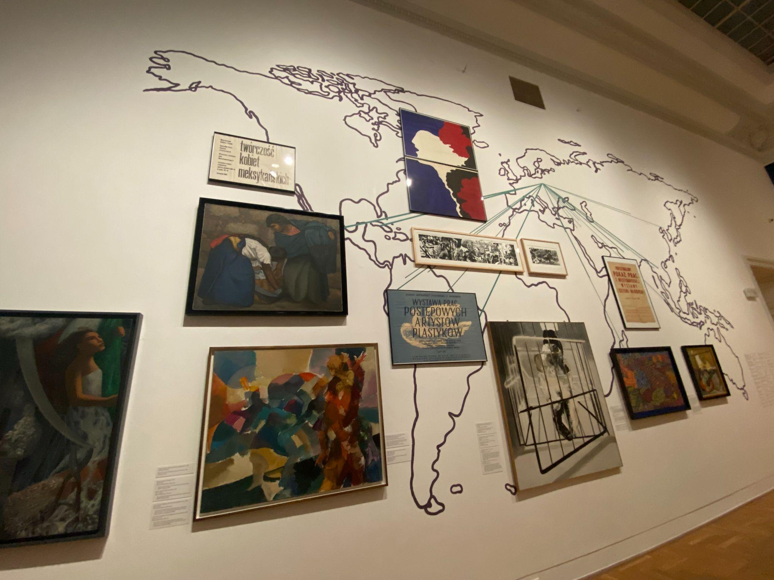
Figure 1. World map with green lines connecting the artwork to Poland. Own photograph, December 2025.

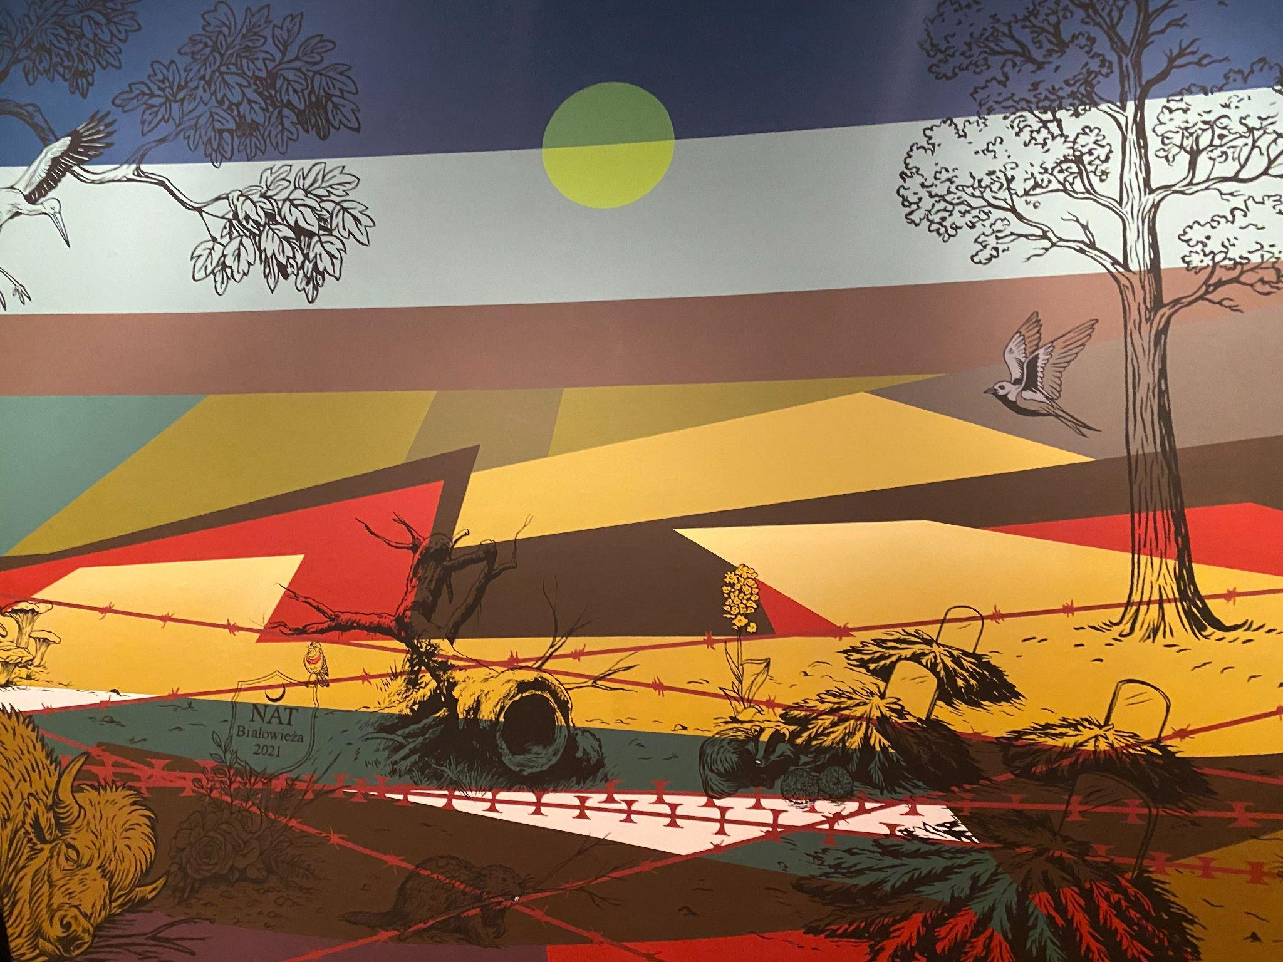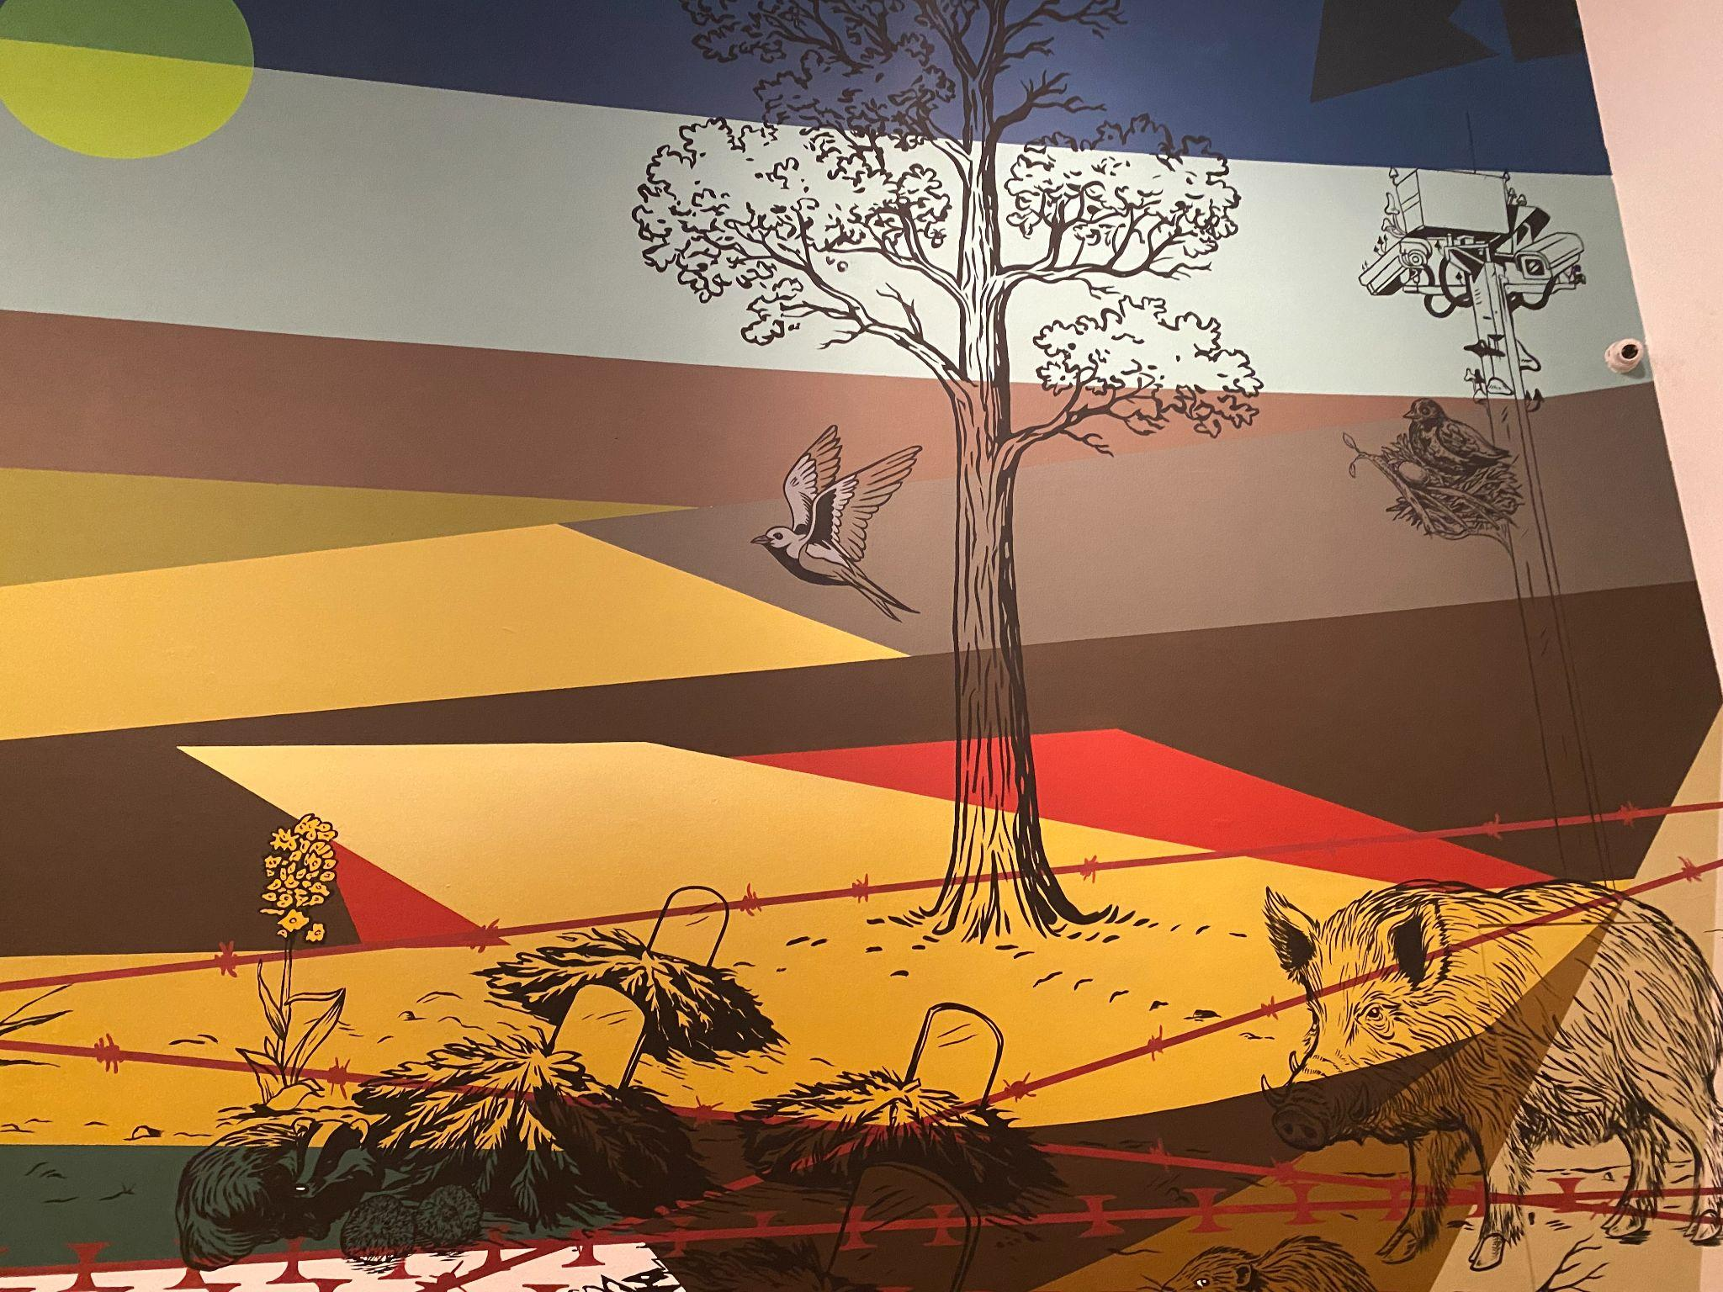
Figure 2. Two sections of Minerva Cuevas’ mural. The photo at the top showcases the NAT signpost along with the animals defying the concept of borders. The photo at the bottom is a detail showing the painted and physical surveillance camera. Own photograph, December 2025.

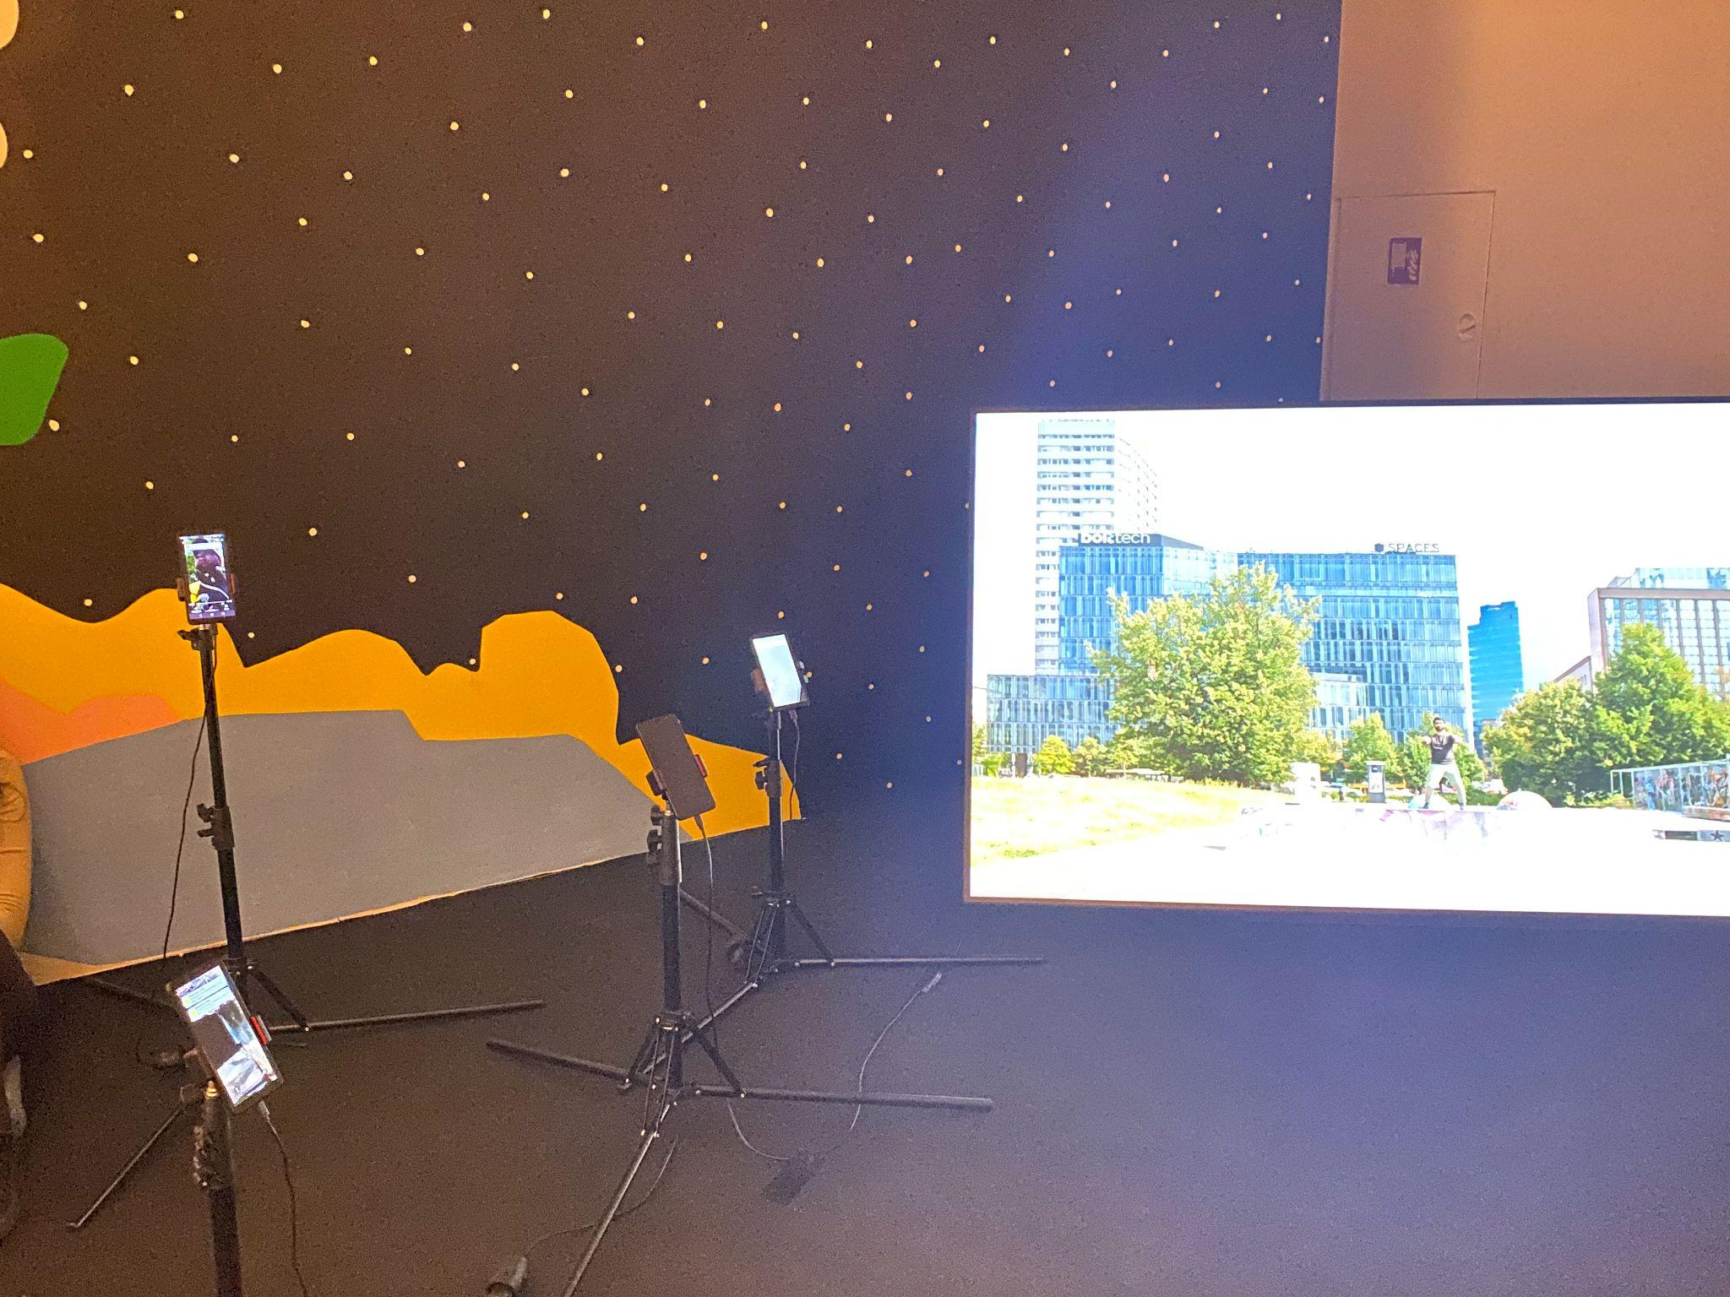
Figure 3. Photo of Drop it Off Station showing the proximity of the group of phones with the large screen. The height of the phones and placement of the TV screen on the ground invite the visitor to sit in front of the installation to better examine it. Own photograph, December 2025.

Bibliography

Andrade, Ana. “Last Night At Playas de Tijuana.” Accessed December 13th, 2025, at https://www.aanandrade.com/en/blank-1-2-1-2.

Anderson, Britta. “Embodiment Against Borders: Discourses of Crisis and Collaborative Performance Art on the U.S.-Mexico Border Wall.” Arizona Journal of Hispanic Cultural Studies, vol. 24 (2020): 129-148. https://www.jstor.org/stable/10.2307/4865342.

Bassnett, Sarah. “Family, Diaspora, and the Politics of Care in Griselda San Martin’s The Wall, 2015-16.” Photography and Culture, vol. 0 (2024): 1-15. https://doi.org/10.1080/17514517.2023.2292457.

Chouliaraki, Lilie and Myria Georgiou. “Introduction: The Digital Border: The Techno-Symbolic Assemblages of Power” in The Digital Border: Migration, Technology, Power. New York University Press, 2022.

Larkin, Brian. “The Politics and Poetics of Infrastructure.” Annual Review of Anthropology 42 (2013): 327–43. http://www.jstor.org/stable/43049305.

Meneses Gutierrez, Mitxy Mabel. “Researching the Mexico-US Border: A Tale of Dataveillance.” Journal of Global Ethics vol. 19 no. 3 (2023): 347–58. doi:10.1080/17449626.2023.2271005.

NPR. “Borderland.” Accessed December 12, 2025, at https://apps.npr.org/borderland/.

Richard K. Broughton, Marta Cholewa, Dorota Czeszczewik, Robert J. Fuller, Bogdan Jaroszewicz, Dries P.J. Kuijper, Marta Maziarz, Grzegorz Mikusinski, and Grzegorz Neubaue. “The Białowieża Forest as an example of the resilience of long-term studies in a changing world.” Biological Conservation, vol. 304 (2025): 2-9. https://doi.org/10.1016/j.biocon.2025.111045.

Stoler, Ann Laura. “Critical incisions: on concept work and colonial recursions” in Duress: Imperial Durabilities in Our Times. Duke University Press, 2016.

Wells, Sarah Ann. “The Scar and the Node: Border Science Fiction and the Mise-En-Scène of Globalized Labor.” The Global South 8, no. 1 (2014): 69–90. https://doi.org/10.2979/globalsouth.8.1.69.

List of Illustrations

Figure 1. Sleep Dealer. Directed by Alex Rivera, Maya Entertainment, 2008. Film still/Screenshot.

Figure 2. Family Portrait. Griselda San Martin, 2016. Color Photograph.

Figure 3. Teeter-Totter Wall. Ronald Rael and Virginia San Fratello and Colectivo Chopeke, 2019. Two photographs by Luis Torres taken from the website Colossal. Color Photographs.

Figure 4. Borderland. NPR. (Screenshot by author, December 12, 2025), from https://apps.npr.org/borderland/. Website.

Figure 5. Last Night at Playas de Tijuana. Ana Andrade. (Screenshot by author, December 13th, 2025) from https://www.aanandrade.com/en/blank-1-2-1-2. Video Installation.

Ann Laura Stoler. “Critical incisions: on concept work and colonial recursions” in Duress: Imperial Durabilities in Our Times. Duke University Press, 2016, 7.
Ibid, 6.
Ibid, 14.
Ibid, 14.
Lilie Chouliaraki and Myria Georgiou. “Introduction: The Digital Border: The Techno-Symbolic Assemblages of Power” in The Digital Border: Migration, Technology, Power. New York University Press, 2022, 5.
Chouliaraki and Georgiou, “Introduction: The Digital Border,” 16.
Anderson, “Embodiment Against Borders,” 134.
Ibid, 134.
Sarah Ann Wells. “The Scar and the Node: Border Science Fiction and the Mise-En-Scène of Globalized Labor.” The Global South 8, no. 1 (2014), 76.
Wells, “The Scar and the Node,” 72.
Ibid, 85
Bassnett, “Family, Diaspora, and the Politics of Care,” 6.
Ibid, 6-7.
Ibid, 3.
Anderson, “Embodiment Against Borders,” 141.
Ibid, 144.
Ibid, 142
Ibid, 143.
Ibid, 143.
“Borderland,” NPR, accessed December 12, 2025, at https://apps.npr.org/borderland/.
NPR, “Borderland”.
“Last Night At Playas de Tijuana,” Ana Andrade, accessed December 13th, 2025, at https://www.aanandrade.com/en/blank-1-2-1-2
Ibid.
Gutierrez Meneses and Mitxy Mabel, “Researching the Mexico-US Border: A Tale of Dataveillance,” Journal of Global Ethics 19, no. 3 (2023), doi:10.1080/17449626.2023.2271005, 356.
Richard K. Broughton, Marta Cholewa, Dorota Czeszczewik, Robert J. Fuller, Bogdan Jaroszewicz, Dries P.J. Kuijper, Marta Maziarz, Grzegorz Mikusinski, Grzegorz Neubaue, “The Białowieża Forest as an example of the resilience of long-term studies in a changing world,” Biological Conservation, 304 (2025). https://doi.org/10.1016/j.biocon.2025.111045, 2.

